Software Architecture and Design Specification
Project: Social Media Management System
Version: 1.0
Authors: Mevin Jose, K Abhiram, Prateek Meher, K Rajeev
Date: September 29, 2025
Status: Draft
Revision History
| Version | Date | Author | Change Summary |
|---|---|---|---|
| 1.0 | 09-29-2025 | Design Team | Architecture document creation |
Approvals
| Role | Name | Signature/Date |
|Team leader|Mevin Jose|29-09-2025|
| Instructor | | |
| Project Manager | | |

1. Introduction

1.1 Purpose
This document specifies the architecture and design of the Social Media Management System (SMMS).

1.2 Scope
This document covers the functional requirements of the Social Media Management System, including authentication, role management, post creation, and scheduling. The design also addresses non-functional aspects such as performance, security, and usability.

1.3 Audience
The target audience for this document includes developers, QA engineers, security auditors, and maintenance teams.

1.4 Definitions
- SMMS: Social Media Management System, the web application under test.
- Admin: A user role with privileges to manage other users and system settings.
- User: A role that can create, schedule, and view posts and analytics.
- Scheduled Post: A post that is stored with a future date and time for automatic publishing.
- Published Post: A post that has been successfully released by the scheduler.

2. Document Overview

2.1 How to use this document
This document provides architectural deliverables, including UML diagrams and API design for the SMMS project.

2.2 Related Documents
- SRS v1.0: Software Requirements Specification for the SMMS.
- STP: Software Test Plan for the SMMS.
- RTM: Requirements Traceability Matrix.

3. Architecture

3.1 Goals & Constraints
Goals: The system should be secure and reliable with high availability.
Constraints: Adherence to security guidelines such as OWASP Top 10 and specific performance requirements like a response time of less than 2 seconds.

3.2 Stakeholders & Concerns
- Users: Concerned with security, ease of use, and system availability.
- Admin: Concerned with maintainability and user management capabilities.
- Developers: Concerned with system modularity and scalability.
- QA Engineers: Concerned with testability and adherence to functional and non-functional requirements.

3.3 Component Diagram
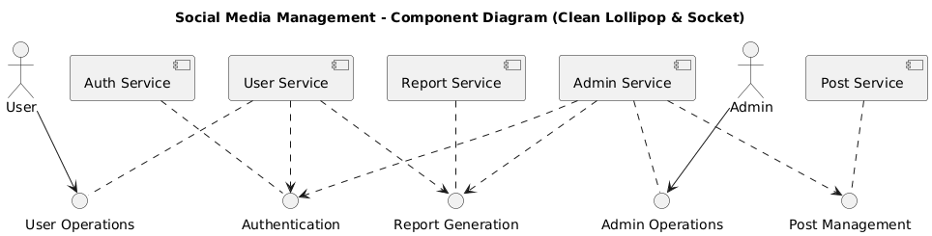

3.4 Component Descriptions
- Authentication Service: Manages user login, registration, and password resets. It includes password hashing and secure credential handling.
- User Management Service: Allows Admins to manage user accounts, including user creation, modification, and deletion.
- Post Management Service: Handles the creation, editing, scheduling and deletion of posts. This service also manages drafts and image uploads.
- Analytics Service: Provides users with a dashboard to view post analytics. It generates reports based on post counts.
- Content Management Service: Enables Admins to manage all content, including deleting posts.

3.5 Chosen Architecture Pattern and Rationale
The chosen architectural pattern is Microservices Architecture.
Rationale:
- Independent Scaling: Services like Post Management and Scheduler can be scaled independently to handle varying loads, while other services like User Management may not require the same level of scaling.
- Parallel Development: Small, independent teams can work on different services (e.g., payments vs. teleconsultation) simultaneously, leading to faster release cycles.
- Fault Isolation: The failure of one service, such as the Analytics Service, will not bring down the entire system, ensuring higher availability.

3.6 Technology Stack & Data Stores
- Backend: Node.js for API services.
- Database: MySQL or MongoDB for data storage.
- APIs: RESTful APIs for communication between services.
- Security: TLS encryption for client-server communication.

3.7 Risks & Mitigations
- Risk: The scheduler component may be unstable.
- Mitigation: Add a mock scheduler for testing and run extensive tests to ensure stability.
- Risk: Security flaws found late in the development cycle.
- Mitigation: Conduct penetration testing early in the process.

3.8 Traceability to Requirements
- SMMS-F-001 (User Registration): Maps to the Authentication Service.
- SMMS-F-005 (Create Post): Maps to the Post Management Service.
- SMMS-F-008 (Schedule Post): Maps to the Scheduler Service.
- SMMS-F-013 (Analytics – post counts): Maps to the Analytics Service.
- SMMS-SR-001 (Password hashing & storage): Maps to the Authentication Service.

3.9 Security Architecture
- Authentication: User credentials will be handled securely using password hashing.
- Access Control: Role-based access controls will be enforced to ensure that unauthorized actions are blocked for both Admin and User roles.
- Data in Transit: All client-server communication will be enforced with HTTPS/TLS 1.2+.
- Input Validation: Perform input validation on all fields (login, post text, image uploads) to prevent common attacks like SQL injection and XSS.
- Session Management: Secure session handling will be implemented, including a session timeout after 15 minutes.
- Threat Modeling: The architecture will be reviewed against the OWASP Top 10 recommendations.

4. Design

4.1 Design Overview
The SMMS is designed with a microservices architecture to provide a clear separation of concerns, which enhances modularity and maintainability.

4.2 UML Sequence Diagrams
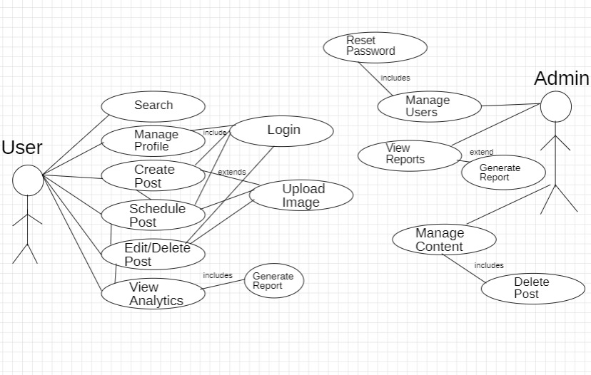

4.3 API Design
Post Management Service API
- Endpoint: /posts/create
- Method: POST
- Request: {userId, content, imageId, scheduledDate}
- Response: {status: "success", postId: "UUID"}
- Errors: 400 Bad Request, 401 Unauthorized
Scheduler Service API
- Endpoint: /schedule/publish
- Method: POST
- Request: {postId}
- Response: {status: "success", message: "Post published"}
- Errors: 404 Not Found (if post ID is invalid)

4.4 Error Handling, Logging & Monitoring
- Error Handling: Standardized error messages will be used, and sensitive information will not be exposed in error logs.
- Monitoring: Key metrics will be monitored, including API response times and system uptime.

4.5 UX Design
The system will be designed with a user-friendly interface. Based on the Use Case Diagram, the UX will be tailored for both User and Admin roles, providing clear flows for tasks such as creating posts, viewing analytics, and managing users.

4.6 Open Issues & Next Steps
- Future Enhancements: Integration with real social media APIs (e.g., Twitter, Facebook) is a planned future enhancement.
- Next Steps: Proceed with detailed design of each microservice and finalize the API specifications.

